**The Shooting Impulse.**

***A Mini Project Report***

***Submitted in Partial Fulfilment for the award of***

**BACHELOR OF TECHNOLOGY**

**IN**

**COMPUTER SCIENCE AND ENGINEERING**

**(Specialization in Gaming Technology)**

***By***

**Arka Mazumdar (19BCG10020)**

**Arpit Singh (19BCG10069)**

**Yashvardhan Pandey (19BCG10089)**

**Kasturi Sai Gana amruth (19BCG0083)**

***Under the Guidance of***

**Dr. Chandan Kumar Behera**

**SCHOOL OF COMPUTING SCIENCE AND ENGINEERING**

**VIT BHOPAL UNIVERSITY,**

**BHOPAL – 466 114, INDIA**

**October, 2020**

**Table of contents**

|  |  |  |
| --- | --- | --- |
| Serial no | Topics | Page no. |
| 1 | Abstract | 3 |
| 2 | Introduction | 4 |
| 3 | Proposed Work | 7 |
| 4 | Software and Hardware requirements | 9 |
| 5 | UML diagrams | 11 |
| 6 | Screenshots of project work | 12 |
| 7 | Conclusion | 15 |
| 8 | Reference | 16 |

**Abstract**

This report describes the process involved in making a 2d game. We have made a game which is playable in Windows (PC) and Mobile platform. It discusses the overview of the game, its programming functions and describes the implementation of the game and is made in complete consideration of entertainment for the people. We have made this game user friendly and can be played by any age group.

**1) Introduction**

1. **Objective**

Shooting Impulse is a 2D side view fantasy world game. It is playable on PC and android/ iOS, both the platforms. It is an endless type game in which the user who controls the cannon has to shoot the impulsive rocks.As this game follows life system process, there is one life given at the first and the player should not lose his/her live in the game by avoiding the impulsive rocks and the player have to destroy the Big rocks,If the Big rocks falls on the player, the character will lose his life and the game will end.

1. **A Brief of Existing work**

The Shooting impulse is a 2d side-view fantasy game. This game is fast paced, challenging and an entertaining game. It is set in a magical world where the core mechanic and goal is to destroy the rocks by shooting swords, but have to avoid hitting rocks, the only obstacle in our game, or we lose our lives. The resource of the game is to get more points by destroying the rocks to score more points. As the points increase the speed of the game will increase double fold. The resolution is if the player loses all the lives the game will return to its starting point.

**c. Limitations of existing work**

While making this game our team faced the following problems:-

1) Our team does not have much experience in 2D programming in unity.

2) The lack of proper resources like not enough screens for programming and game/scene arrangements.

3) Low budget constraints and Team members having different opinions on how the game works or should work which makes it little time consuming to get on the same page to work together.

4) Minor interaction with the teammates and lack of workspace and focus driven environment.

5) The other limitations are yet to be faced because we have not completed the project.

**2. Proposed work**

**a. Brief of proposed approach**

We first of all started with the making up of a story so that we can get a baseline story on which we will further be working on. After getting the story, we discussed what type dimension we will be working on, whether it should be 2D, 2.5D or 3D so that we can present our story based game in a very unique way.

Groups were made of 2 to work on each work, i.e. animation and scene, and the other was for the starting animation to give a background about the story of the game.

We then made the assets of the game, which then was used in our game to run the game. After the assets, the working on its animation was done and so was the working of the scenes.

The animation and scene management in which the main menu exists, was done separately and was integrated at the end together. Polishing and changes were made later.

**b. Advantages of the proposed system**

1. Making our groups divided into two each made the creation of the game complete with efficiency.
2. By deciding on the dimension, it helped us to view the game in that particular way and produce the game at its best.
3. The Standard assets which were used to affiliate with the creation of the game were quite notable as we didn’t expect it would turn out to be eye-catching.
4. The theme of the game thoroughly matched with the concept of our game.
5. The concept of our game perfectly matches with the 2d side view version if we use 3D it won’t look attractive. Instead it might turn out to be a boring game, as we were down on the fact of texturing in unity.
6. By doing the animation and the scene management separately, it helped us a lot to organise things in an individual manner, and when we had to integrate, we had nothing to do more than attaching the files together.
7. We are yet to polish our finished game, because we are working on it.

**3. Software and Hardware requirements**

* 1. **Software requirements**

1. Unity 3d
2. Paint 3D editor.
3. 32-bit/64-bit Windows OS.
4. Android/iOS.
5. 100 MB space

**b. Hardware requirements**

We have made a 2D side scroller game which is supported for PC as well as for mobile.

For Windows, we have the following hardware requirements:-

1) CPU- Intel Core i5-7500 or better.

2) RAM- 6GB of system memory.

3) Graphics card:- NVIDIA GeForce GTX 1050 or AMD Radeon RX 580

4) GPU memory - 6GB of video memory.

For Mobile, we have the following hardware requirements:-

1) Android, IOS, Mobile OS

2) Version- android 5.1 or High, IOS 6.0 or Higher

3) Processor – 480 or additional

4) Frequency – 2 GHz Min.

**UML Diagram:**

As we have not completed our game, we are yet to work upon the UML diagram.

**Screenshots of Our Project:-**

The screenshot for our game are as follows:-

**Main Menu**

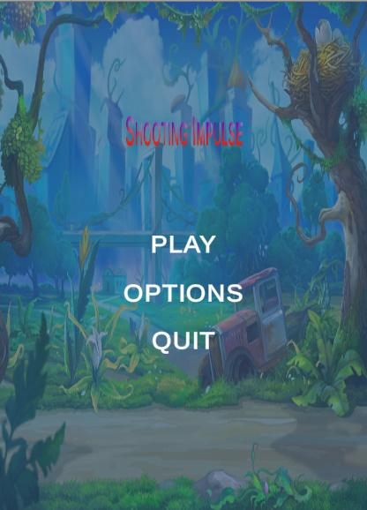

Fig:- Main Menu of the game.

Main menu loads when the game is launched. It has 3 buttons which will help in navigating in the game scene

**Play-** It loads the main game scene to play

**Options-** It loads another text and buttons panel which has all the game settings like volume. Inside this it has a slider which increases or decreases the game volume

**Pause Menu**

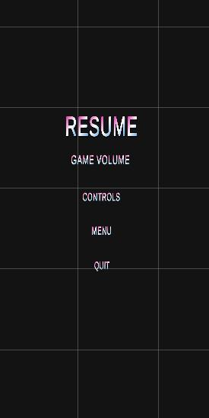

Fig:- Pause Menu of the game.

Pause Menu is launched when we want to pause the game.

**Game Volume:-**Game volume helps in adjusting the volume of the game.

**Controls:-** Controls gives us a brief description about how the game controls work.

**Animations**

It has the animation of the Playable object, cannon which shoots swords.There is one life given at the first and the player should not lose his/her live in the game by avoiding the impulsive numbered rocks and the player have to destroy these rocks. If the Big rocks falls on the player, the character will lose his life and the game will end.

**Gameplay**

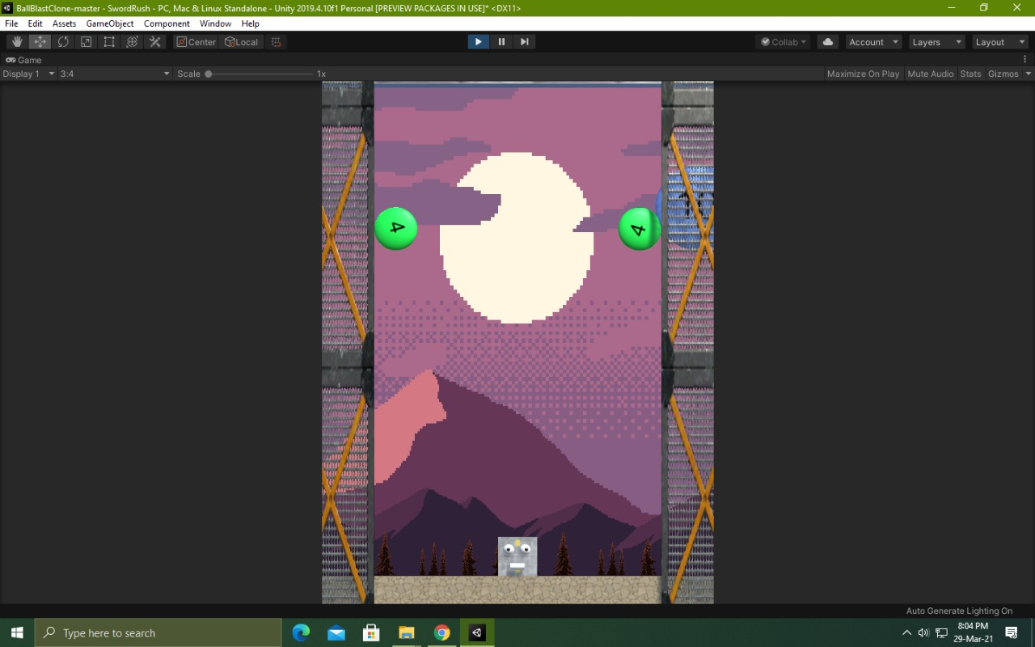

Fig:-Gameplay

Note : As this is a level-based game, we are yet to add more levels to it. The screenshot represents a box, which will be later turned into a cannon as there will be a change in the assets too.

**Conclusion**

We have learnt a lot from this project and it has drastically sharpened our concept on game programming, animation software-hardware interface and learning about different types of documentation.

Working with a game engine that took on a 2D environment was a completely new experience for use, where we learnt to make use of sprites and assets.

We made use of codes for each and every animation on our own, as we had to make changes at every point of the game to make it look better than our scratch idea.

Overall it was a great experience to be working on a game by using our own ideas in a coordinated way to give out an original game

**Reference**

1. · <https://www.slideshare.net/NadiaIIT/final-project-report-of-a-game>.
2. · Unity asset store(Joystick only)
3. · Google.com (website).
4. · YouTube.com (tutorials).
5. · Unity official docs.
6. · Remove.bg (website).
7. · Unity scripting API.
8. Google sprite spreadsheets (sprites).